Test Exercise
Name: Charmaine Godolphin
Part 1

- What things do you need to consider when taking a liquid sample?
First consideration with any task should always default to H&S. Obtaining and internalising the contents of the task SOPs and RAs would ensure the operator is armed with the knowledge required to complete the task in a safe manner having gained awareness of associated risks and control measures. Consulting these documents fulfils the operators responsibility under H&S Law, and ensures compliance with the organisations policies. In addition to this, sampling techniques and frequencies form part of the site's permit requirements , so it is essential to complete this task in accordance with the SOP.
Factors which may affect the sampling process from a technical perspective could include:
Cross Contamination - Taking a sample from a groundwater borehole using equipment which has been contaminated with Leachate could have a significant impact on the sample results.
Sample Location & Labeling of Samples - It’s likely that a given site would have a number of sample locations as typically the site would be required to test :
- groundwater
- leachate quality pre-treatment, l
- leachate quality post treatment, and
- final disposal leachate quality.
It is therefore essential to ensure liquid samples are clearly marked to ensure the results from the sample analysis remain valid

- How can incorrect sampling affect the results returned from lab analysis?
Sample materials lab results can be affected by simple things such as incorrect labelling, or incorrect handling. Incorrect handling could have a significant impact in the sample as it could potentially alter the original sample’s properties, which would in turn affect the lab analysis. For a sample to retain its original properties, it has to be handled in a method which would ensure the sample remains stable following the act of sampling, and covering the period leading up to and including the lab analysis. Failure to maintain the sample’s integrity could lead to inaccurate results which could have a financial impact as the organisation is likely to either require further sampling to confirm the result or as remediation strategies are adopted based on the lab results. There organisation is also required to report on these results, especially when there are trigger breaches, so incorrect results could also affect this. ……………………………………………………………………………………………

- What is stability when considering liquid samples?
The stability of a liquid sample is the sampled material’s ability to maintain its original properties from the time of sampling to the point of analysis. …………………………………………………………………………………………
……………………………………………………………………………………………………………
……………………………………………………………………………………………………………
……………………………………………………………………………………………………………

- The graph below shows the level of Ammoniacal nitrogen in a borehole (BH13 - 83601013). The compliance/trigger level for the well is set at 1.45mg/l.

Describe the trend shown.

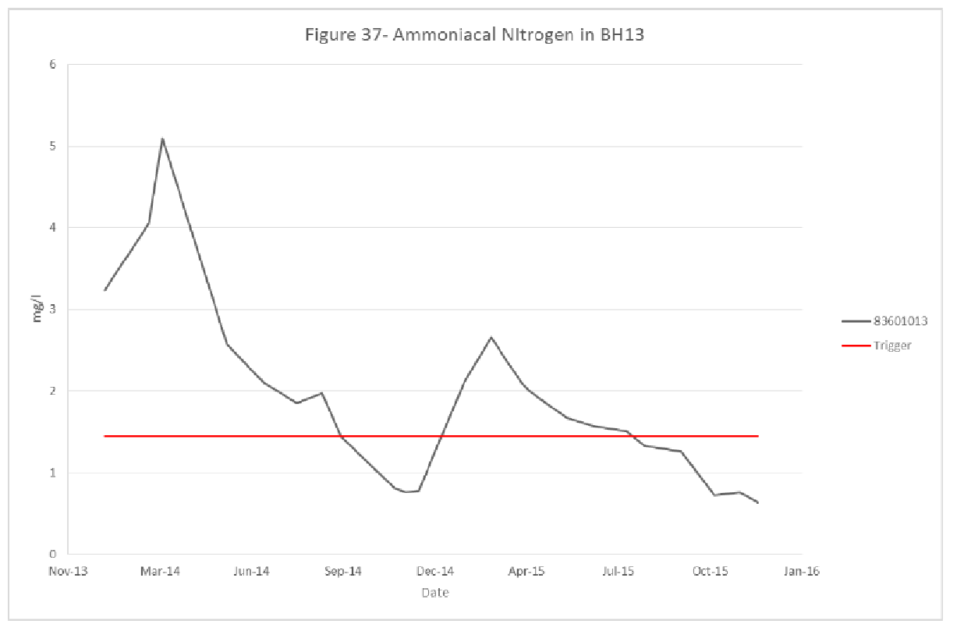
The trend indicates the level of Ammoniacal nitrogen in a borehole BH13 - 83601013 is continuing a downward trend on the whole. Although the latest data shows the borehole is below the trigger level, there appears to be a seasonal trend which would suggest the levels might rise again. It would be useful to trend the data against rainfall to see if the reduction in ammoniacal nitrogen is likely due to dilution from increased rainfall. ……………………………………………………………………………………………………………
……………………………………………………………………………………………………………
……………………………………………………………………………………………………………
……………………………………………………………………………………………………………
……………………………………………………………………………………………………………

- The graph below shows the leachate level in leachate well 1 and rainfall. Please describe the trend shown in the graph.

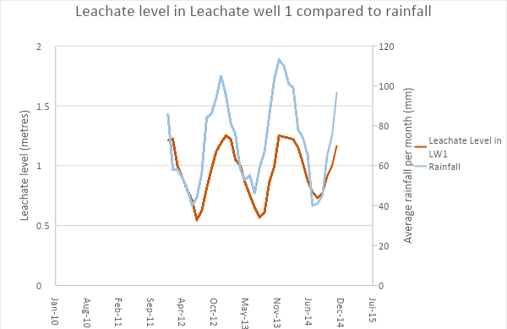

The graph illustrates a direct correlation between the rainfall and Leachare in leachate well LW1. The trend indicates that the leachate level fluctuates as per the rainfall experienced on the site which suggests rainwater is entering the site and the validity of the capping should be investigated…………………………………………………………………………………………
……………………………………………………………………………………………………………
……………………………………………………………………………………………………………
……………………………………………………………………………………………………………
……………………………………………………………………………………………………………

Part 2 - Excel

- The excel file you have been given contains the data for a number gas boreholes. Using excel please graph the CH4 results for boreholes 83311901 and 83311902 for the two year period. Once completed please save the file onto ‘desktop’ using your name as the file name.
Please comment on any trends found in the graph.
The graph shows a lot of noise for BH 83311901 which warrants further investigation as data fluctuations like this could suggest a potential data / sampling error. ……………………………………………………………………………………………………………
……………………………………………………………………………………………………………
……………………………………………………………………………………………………………
……………………………………………………………………………………………………………

- Using the data set provided determine which borehole and on which date the maximum value of CO2 was recorded.
Maximum CO2 was recorded on Borehole 83311901 on 10/28/2014. The CO2 value recorded was 33.2% …………………………………………………………………………...……………………
………………………………………………………………………………

- Determine the mean value of CO2 in borehole 83311901 using the excel file provided.
12.95……………………………………………………………………………………
……..……………………………………………………………………………………

- Determine the 95th percentile for the CH4 values in borehole 83311901 using the excel file provided.
…………56.31……………………………………………………………………………………
……………………………………………………………………………………………………………

Part 3 - Maths Questions

- Put the following in 24hr clock format
9.20am - 09:20
10.36pm - 22:36
12.01am - 00:01

- Please complete the following

89+ 123+ 98+
65+ 42+ 32+
12 12 12

166

142

177

148 - 188 - 79+
23 135 69 -
23

125

53

125

- A set of 20 leachate pumps are set to run one after the other. They are programmed to start at 16:30. Each pump will run for 10 minutes. Half way through the cycle there is a break of 15 minutes to allow the receiving tank to settle. At what time will the last pump switch off? Give the answer using the 24hr clock.
00:50

- A site has spent £47,840 on plant maintenance during the financial year. The site was budgeted to spend £52,000 for the year.
What percentage has the site under spent the budget?
8%

- What is 634 divided by 0.1?

6340

Part 4 - Priority Exercise
You have the following tasks to complete for the day. You arrive on site and it is already busy with vehicles and it is raining.

How will you prioritise these tasks and why?

- You have to complete your monthly report and send to the General Manager
- Samples of fines have to be taken as they are due to be collected early afternoon
- A pump needs to be installed on the edge of a cell where leachate is ponding.
- Prepare for the site health and safety meeting which is due to be held that evening.

Ring the general manager to explain the issues affecting the site, and explain that site works need to take priority, but that their monthly report will be completed later that evening. If they urgently require the information, the task is desk bound so can be completed from home, however, there is also a slight possibility the manager might not need the data and you could potentially move this task to the next day.
B. Collect Sample fines as the organisation is legally obliged to obtain this data at a set frequency, and also because the courier is book to collect in the afternoon.
C. Arrange / Install a pump on the edge of the cell where the leachate is ponding as this is an environmental matter and again, needs to be resolved promptly to satisfy the regulator.
D. Prepare for the H&S meeting which is taking place in the evening. You should already have most of the information to hand if the meeting was scheduled, so there should be time for a few amendments before the meeting starts.
A.complete your monthly report and send it to the General Manager.

